Department Of Computer Science And Engineering
University Of Dhaka
Software Project Title : SURVIVING CAR
Prepared by :
Apu Kumar Chakroborti
Roll:50
Habibullah
Roll:38
Prepared for:
Dr. Muhammad Asif Hossain Khan
Anna Fariha
Lecturer,Department Of Computer Science And Engineering, University of Dhaka.
Introduction:
This is a simple game of car surviving . This program is written in the language C and using Microsoft Visual C++ compiler.
Description:
There are three lanes in the game window. Enemy cars are coming from every lane in a different time .There is a car in the bottom of the window and the player has to move the car to avoid collision from the enemy car .
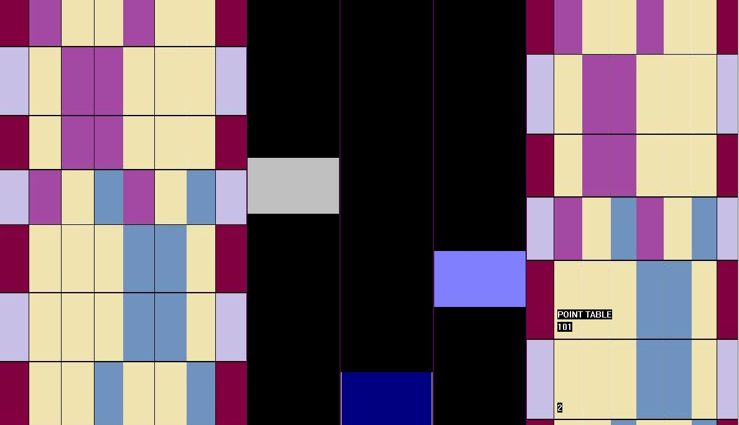
Though there is no level in the game it has different difficulty as the score goes up.
By pressing ‘a’ or ‘s’ or ‘d’ car can be moved.

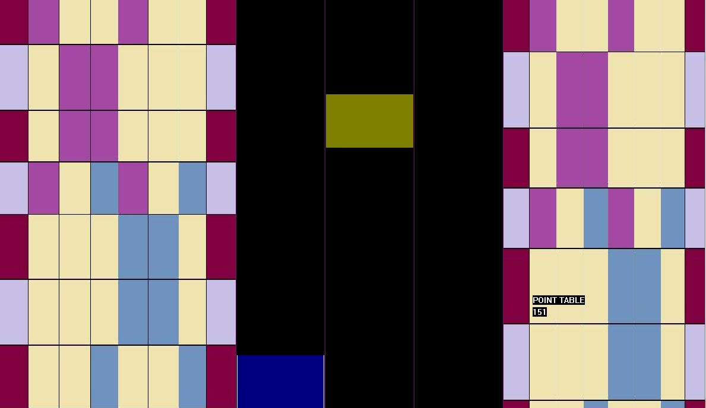
If any enemy car either touch or run over the player car game will be over.
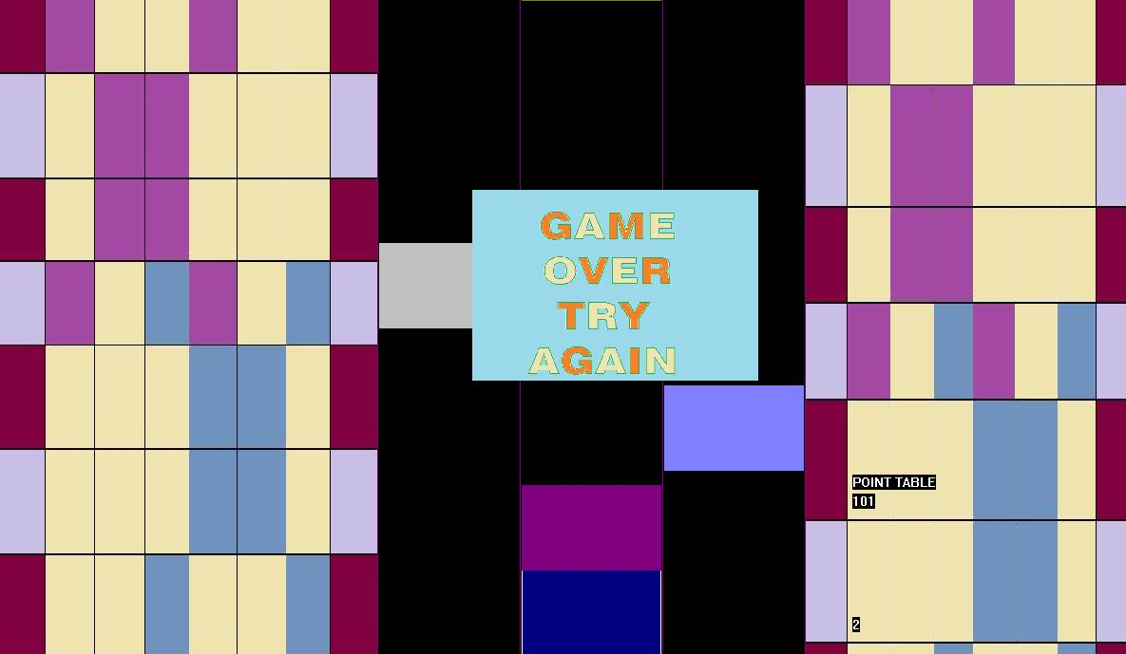

Description of the user defined functions:
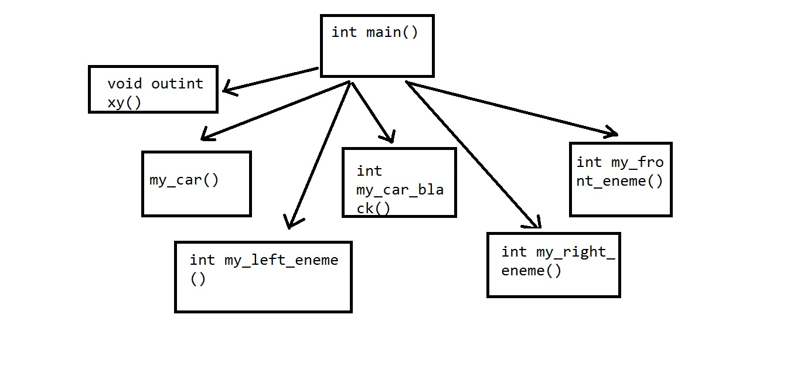

- int my_car(int leftm,int chek3,int chek4,int position): shows my car in the window. It returns the car’s current position(left and right).
- int my_car_black(int leftm): when my car is moved previous car will be black.it returns 0.
- int my_front_enemy(int y,int chek5,int chek6,int position): enemy cars come towards my car through middle lane. It returns my cars current position. It also check whether game over or not.
- int my_left_eneme_car(int y,int chek7,int chek8,int position) : enemy cars come towards my car through left lane. It returns my cars current position. It also check whether game over or not.
- int my_right_eneme_car(int yy,int chek9,int chek10,int position): enemy cars come towards my car through right lane. It returns my cars current position. It also check whether game over or not.
- void outintxy(int x, int y, int value): prints the score.

Header files used in the project :
1. Header file stdio.h: This header file is used for these functions:
getch(): Takes character input .
2. Header file stdlib.h: exit(0): Exits the program.
3. Header file conio.h: kbhit(): Detects any hit from the keyboard.
gotoxy(): Moves cursor to the (x, y) position.
4. Header file graphics.h:
initwindow(): Get a window .
setcolor(): Sets the current colour.
outtextxy(): Shows message on a given coordinate.
rectangle(): Draws a rectangle.
setfillstyle(): Imposes the colour and pattern of filling.
bar(): Draws a solid rectangle.
line(): Draws a line between two given coordinates.
Readimagefile():to load a image.

Source Code:

#include"graphics.h"
//#include <stdlib.h>
//#include <stdio.h>
//#include <conio.h>
//#include "winbgim.h"
char key;
int chek1,chek2;
int in1,in2;
char name[20];
int my_car_black(int leftm)
{
int count;
int x=0;
setfillstyle(SOLID_FILL,0);
setcolor(0);
bar(leftm+552+x,600,leftm+698+x,690);
rectangle(leftm+552+x,600,leftm+698+x,690);
return 0;
}
int my_car(int leftm,int chek3,int chek4,int position)
{
int count;
int a,b,c,d;
int x=0;

setfillstyle(SOLID_FILL,1);
setcolor(1);
bar(leftm+552+x,600,leftm+698+x,690);
rectangle(leftm+552+x,600,leftm+698+x,690);
//readimagefile("game_hero.jpg",leftm+552+x,600,leftm+698+x,690);

count=2;
position=count;
chek3=leftm+552+x,chek4=630;
return (leftm,chek3,chek4,position);
}

int my_front_enemy(int y,int chek5,int chek6,int position)
{
int val=0;
//val=-y;
int num=0;
num=chek6;
int z=0;
int chek3,chek4,push=-400;
//MY FRONT ENYMY

setfillstyle(SOLID_FILL,5);
setcolor(5);
bar(552+z,0+y+val,698+z,90+y);
rectangle(552+z,0+y+val,698+z,90+y);
//delay(200);
setfillstyle(SOLID_FILL,0);
setcolor(0);
bar(552+z,0+y+val-90,698+z,90+y-90);
rectangle(552+z,0+y+val-90,698+z,90+y-90);

setfillstyle(SOLID_FILL,6);
setcolor(6);
bar(552,0+y+val+push,698,90+y+push);
rectangle(552,0+y+val+push,698,90+y+push);
//delay(200);
setfillstyle(SOLID_FILL,0);
setcolor(0);
bar(552,0+y+val-90+push,698,90+y-90+push);
rectangle(552,0+y+val-90+push,698,90+y-90+push);
chek3=552+z,chek4=90+y;
int chekf1,chekf2=90+y+push;
int up1=0,up2=0;
up2=0+y+val+push;
up1=0+y+val;
//down chek
if(chek4>=600&&chek4<=614&&position==2&&chek3==chek5)
{
readimagefile("apu1.jpg",500,200,800,400);
outtextxy(900,600,"GAME OVER");
scanf("%s",name);
//scanf("%s",name);
exit(1);
}
else if(chekf2>=600&&chekf2<=614&&position==2&&chek3==chek5)
{
readimagefile("apu1.jpg",500,200,800,400);
outtextxy(900,600,"GAME OVER");
scanf("%s",name);
//scanf("%s",name);
exit(1);
}

//up chek
else if(up1>=600&&up1<=614&&position==2&&chek3==chek5)
{
readimagefile("apu1.jpg",500,200,800,400);
outtextxy(900,600,"GAME OVER");
scanf("%s",name);
//scanf("%s",name);
exit(1);
}
else if(up2>=600&&up2<=614&&position==2&&chek3==chek5)
{
readimagefile("apu1.jpg",500,200,800,400);
outtextxy(900,600,"GAME OVER");
scanf("%s",name);
//scanf("%s",name);
exit(1);
}
else if(up1>=600+90&&up1<=614+90&&position==2&&chek3==chek5)
{
readimagefile("apu1.jpg",500,200,800,400);
outtextxy(900,600,"GAME OVER");
scanf("%s",name);
//scanf("%s",name);
exit(1);
}
else if(up2>=600+90&&up2<=614+90&&position==2&&chek3==chek5)
{
readimagefile("apu1.jpg",500,200,800,400);
outtextxy(900,600,"GAME OVER");
scanf("%s",name);
//scanf("%s",name);
exit(1);
}
position=2;
return (y,chek5,chek6,position);
}

int my_left_eneme_car(int y,int chek7,int chek8,int position)
{
int val=0;
// val=-y;
int num=0;
num=chek8;
int chek3,chek4;
//int zz,add,back;
int z=0,zz=0,add=-250,back=-200,push=-240;
//readimagefile("game6.jpg",552+z,0+y+val,698+z,90+y);
setfillstyle(SOLID_FILL,7);
setcolor(7);
bar(402+z,add+0+y+val,548+z,add+90+y+val);
rectangle(402+z,add+0+y+val,548+z,add+90+y+val);
//delay(200);
setfillstyle(SOLID_FILL,0);
setcolor(0);
bar(402+z,add+0+y+val-90,548+z,add+90+y+val-90);
rectangle(402+z,add+0+y+val-90,548+z,add+90+y+val-90);

setfillstyle(SOLID_FILL,8);
setcolor(8);
bar(402,add+0+y+val+push,548,add+90+y+val+push);
rectangle(402,add+0+y+val+push,548,add+90+y+val+push);
//delay(200);
setfillstyle(SOLID_FILL,0);
setcolor(0);
bar(402,add+0+y+val-90+push,548,add+90+y+val-90+push);
rectangle(402,add+0+y+val-90+push,548,add+90+y+val-90+push);
//enemy car
//1
int chekl1,chekl2;
chek3=402+z,chek4=add+90+y;
chekl2=add+90+y+val+push;
int lef1=0,lef2=0;
lef1=add+0+y+val;
lef2=add+0+y+val+push;

//front up chek
if(chek4>=600&&chek4<=614&&position==1&&(chek3==chek7))
{
readimagefile("apu1.jpg",500,200,800,400);
//outtextxy(900,600,"GAME OVER");
scanf("%s",name);
outtextxy(900,565,name);
delay(200);
exit(1);
}

else if(chekl2>=600&&chekl2<=614&&position==1&&(chek3==chek7))
{
readimagefile("apu1.jpg",500,200,800,400);
//outtextxy(900,600,"GAME OVER");
scanf("%s",name);
outtextxy(900,565,name);
delay(200);
exit(1);
}
//front down chek
else if(chek4>=600+90&&chek4<=614+90&&position==1&&(chek3==chek7))
{
readimagefile("apu1.jpg",500,200,800,400);
//outtextxy(900,600,"GAME OVER");
scanf("%s",name);
outtextxy(900,565,name);
delay(200);
exit(1);
}

else if(chekl2>=600+90&&chekl2<=614+90&&position==1&&(chek3==chek7))
{
readimagefile("apu1.jpg",500,200,800,400);
//outtextxy(900,600,"GAME OVER");
scanf("%s",name);
outtextxy(900,565,name);
delay(200);
exit(1);
}
//back up chek
else if(lef1>=600&&lef1<=614&&position==1&&(chek3==chek7))
{
readimagefile("apu1.jpg",500,200,800,400);
//outtextxy(900,600,"GAME OVER");
scanf("%s",name);
outtextxy(900,565,name);
delay(200);
exit(1);
}

else if(lef2>=600&&lef2<=614&&position==1&&(chek3==chek7))
{
readimagefile("apu1.jpg",500,200,800,400);
//outtextxy(900,600,"GAME OVER");
scanf("%s",name);
outtextxy(900,565,name);
delay(200);
exit(1);
}
position=1;
return (y,chek7,chek8,position);
}

int my_right_eneme_car(int yy,int chek9,int chek10,int position)
{
// int zz,add,back;
int val=0;
// val=-yy;
int num=0;
num=chek10;
int add=-300,back=-100,push=-700;

int chek3,chek4;

setfillstyle(SOLID_FILL,9);
setcolor(9);
bar(702,back+0+yy+val,848,back+90+yy);
rectangle(702,back+0+yy+val,848,back+90+yy);
//delay(200);

setfillstyle(SOLID_FILL,0);
setcolor(0);
bar(702,back+0+yy+val-90,848,back+90+yy-90);
rectangle(702,back+0+yy+val-90,848,back+90+yy-90);

setfillstyle(SOLID_FILL,10);
setcolor(10);
bar(702,back+0+yy+val+push,848,back+90+yy+push);
rectangle(702,back+0+yy+val+push,848,back+90+yy+push);
//delay(200);
setfillstyle(SOLID_FILL,0);
setcolor(0);
bar(702,back+0+yy+val-90+push,848,back+90+yy-90+push);
rectangle(702,back+0+yy+val-90+push,848,back+90+yy-90+push);
int chekf1,chekr2;
chek3=702,chek4=back+90+yy;
chekr2=back+90+yy+push;
int rig1=0,rig2=0;
rig1=back+0+yy+val;
rig2=back+0+yy+val+push;
//front up chek
if(chek4>=600&&chek4<=614&&position==3&&(chek3==chek9))
{
readimagefile("apu1.jpg",500,200,800,400);
outtextxy(900,600,"GAME OVER");
scanf("%s",name);

exit(1);
}

else if(chekr2>=600&&chekr2<=614&&position==3&&(chek3==chek9))
{
readimagefile("apu1.jpg",500,200,800,400);
//outtextxy(900,600,"GAME OVER");
scanf("%s",name);

exit(1);
}
//front down chek
else if(chek4>=600+90&&chek4<=614+90&&position==3&&(chek3==chek9))
{
readimagefile("apu1.jpg",500,200,800,400);
outtextxy(900,600,"GAME OVER");
scanf("%s",name);

exit(1);
}

else if(chekr2>=600+90&&chekr2<=614+90&&position==3&&(chek3==chek9))
{
readimagefile("apu1.jpg",500,200,800,400);
//outtextxy(900,600,"GAME OVER");
scanf("%s",name);

exit(1);
}
//back up chek

else if(rig1>=600&&rig1<=614&&position==3&&(chek3==chek9))
{
readimagefile("apu1.jpg",500,200,800,400);
outtextxy(900,600,"GAME OVER");
scanf("%s",name);

exit(1);
}

else if(rig2>=600&&rig2<=614&&position==3&&(chek3==chek9))
{
readimagefile("apu1.jpg",500,200,800,400);
//outtextxy(900,600,"GAME OVER");
scanf("%s",name);

exit(1);
}
position=3;
return (yy,chek9,chek10,position);
}
void outintxy(int x, int y, int value)
{

char digit_string[20];

sprintf(digit_string, "%d", value);

outtextxy(x, y, digit_string);

}

int main()
{
//if(ismouseclick(WM_LBUTTONDOWN))

int car_position;
char score[10];
int count=0;
//char apu="";
int leftm=0;
//my_car(leftm);
//getdisplaycolor(WHITE);

int incre=100,decre=-100,add=300,sub=-300;
int left=100,right=200,bottom=300,top=400,e=500,f=600,g=10;
int left1=400,right1=850,top1=0,bottom1=690;
initwindow(1200,700,"CAR GAME");

//left_side
readimagefile("side13.jpg",0,0,left1,bottom1);
//right_side
readimagefile("side13.jpg",850,0,1200,800);

//road
setfillstyle(SOLID_FILL,RED+BLUE);
setcolor(RED+BLUE);
bar(left1,top1,left1,bottom1);
line(left1,top1,left1,bottom1);
line(right1,top1,right1,bottom1);
line(550,0,550,690);
line(700,0,700,690);
int x=0;
int point=0,position=0;
//count=0;
int chek1=0,chek2=0;
//my_car(leftm,chek1,chek2,position);
int y=0,z=0,yy=0,zz=0;
int max=1600;
int in1=5,in2=5;
int a,b;

my_car(0,552,0,2);

y=0,yy=0;
char prevkey='s';
//for(;y<=1000&&yy<=max;y=y+60,yy=yy+60)
car_position=552;
//chek1=552;
while(1)
{
if(count<=300)
{
y=y+5,yy=yy+5;
}
else if(count>=301&&count<=1000)
{
y=y+10,yy=yy+10;
}
else
{
y=y+15,yy=yy+15;
}
chek2=5;

outintxy(900,520,count);
outtextxy(900,500,"POINT TABLE");

//sprintf("%d","point");
if(kbhit())
{
key=getch();
prevkey=key;
//left
if(key=='a')
{
leftm=-150;
chek1=-150+552;
//car_position=chek1;
my_car(leftm,chek1,chek2,position);
//chek1=chek1+150;
my_car_black(0);
//chek1=chek1+150;
my_car_black(150);
my_front_enemy(y,chek1,chek2,1);
//my_front_enemy_black(y,chek1,chek2,1);

//my_left_eneme_car_balck(y-5,chek1,chek2,1);
my_left_eneme_car(y,chek1,chek2,1);
// my_left_eneme_car_balck(y,chek1,chek2,1);
my_right_eneme_car(yy,chek1,chek2,1);

}
else if(key=='d')
{
leftm=150;
chek1=552+150;
chek2=5;
my_car(leftm,chek1,chek2,position);
my_car_black(-150);
my_car_black(0);
my_front_enemy(y,chek1,chek2,3);
my_left_eneme_car(y,chek1,chek2,3);
my_right_eneme_car(yy,chek1,chek2,3);

}
else if(key=='s')
{
leftm=0;
chek1=552+0;
chek2=5;
my_car(leftm,chek1,chek2,position);
my_car_black(150);
my_car_black(-150);
my_front_enemy(y,chek1,chek2,2);
my_left_eneme_car(y,chek1,chek2,2);
my_right_eneme_car(yy,chek1,chek2,2);

}
}
else
{
//left
if(prevkey=='a')
{
leftm=-150;
chek1=-150+552;
my_car(leftm,chek1,chek2,position);
my_car_black(0);
my_car_black(150);
my_front_enemy(y,chek1,chek2,1);
my_left_eneme_car(y,chek1,chek2,1);
my_right_eneme_car(yy,chek1,chek2,1);

}
else if(prevkey=='d')
{
leftm=150;
chek1=552+150;
my_car(leftm,chek1,chek2,position);
my_car_black(-150);
my_car_black(0);
my_front_enemy(y,chek1,chek2,3);
my_left_eneme_car(y,chek1,chek2,3);
my_right_eneme_car(yy,chek1,chek2,3);

}
else if(prevkey=='s')
{
leftm=0;
chek1=552+0;
my_car(leftm,chek1,chek2,position);
my_car_black(150);
my_car_black(-150);
my_front_enemy(y,chek1,chek2,2);
my_left_eneme_car(y,chek1,chek2,2);
my_right_eneme_car(yy,chek1,chek2,2);

}
}

my_car(leftm,chek1,chek2,position);

score[0]=2+'0';
score[1]='\0';
outtextxy(900,650,score);

count=count+1;
printf("%d\n", count);

if(yy>=max)
{
yy=0,y=0;
//count+=1;
//count=count%100;
}
delay(1);
}
return 0;
}

Limitations:
This project has a few drawbacks. These draw backs
are as follows :
- There no level that can be direct played.
- We have use there keys but it less the game’s fun as its become easy though we tried to give the enemy car more speed.
- There no menu bar .
- The graphical environment of this project is not
attractive enough.

Conclution :

In spite of limitations this game may be enjoyable to the player. The game runs under the graphical driverBGI . We hope that in future,
we will be able to extend this game. make the graphical environment
look better. It was our first step to make any game or software. The coding was enjoyable for us.

References:
This project is done according to our teacher’s idea. We are grateful to our friends who helped us in our project. And to be honest the main reference was turbo C help file. We think that this is enough to establish the graphical environment. Some books for library functions and syntax:
- Programming in ANSI C- E Balagurusamy.

